**Assignment No.11**

**Roll No:-**

**Q. Write ASP.NET program to demonstrate Server-Side State Management.**

**1) Design Code:-** (*SessionDemo2.aspx*)

<%@ Page Language="C#" AutoEventWireup="true" CodeBehind="SessionDemo2.aspx.cs" Inherits="ClientSideState.SessionDemo2" %>

<!DOCTYPE html>

<html xmlns="http://www.w3.org/1999/xhtml">

<head runat="server">

<title></title>

<style type="text/css">

.auto-style1 {

width: 100%;

}

.auto-style2 {

width: 203px;

}

</style>

</head>

<body>

<form id="form1" runat="server">

<div>

&nbsp;&nbsp;&nbsp;&nbsp;&nbsp;&nbsp;&nbsp;&nbsp;&nbsp;&nbsp;&nbsp;&nbsp;&nbsp;&nbsp;&nbsp;&nbsp;&nbsp;&nbsp;&nbsp;&nbsp;&nbsp;&nbsp;&nbsp;&nbsp;&nbsp;&nbsp;

<asp:Label ID="Label5" runat="server" Font-Bold="True" Font-Size="X-Large" Text="Client Side State Management"></asp:Label>

(Session)</div>

<table class="auto-style1">

<tr>

<td class="auto-style2">

<asp:Label ID="Label1" runat="server" Font-Bold="True" Font-Size="X-Large" Text="UserName:"></asp:Label>

</td>

<td>

<asp:TextBox ID="TextBox1" runat="server"></asp:TextBox>

</td>

<td>&nbsp;</td>

</tr>

<tr>

<td class="auto-style2">

<asp:Label ID="Label2" runat="server" Font-Bold="True" Font-Size="X-Large" Text="Password:"></asp:Label>

</td>

<td>

<asp:TextBox ID="TextBox2" runat="server"></asp:TextBox>

</td>

<td>&nbsp;</td>

</tr>

<tr>

<td class="auto-style2">&nbsp;&nbsp;&nbsp;&nbsp;&nbsp;&nbsp;&nbsp;&nbsp;&nbsp;&nbsp;&nbsp;&nbsp;&nbsp;&nbsp;&nbsp;&nbsp;&nbsp;&nbsp;&nbsp;&nbsp;&nbsp;&nbsp;&nbsp;&nbsp;

<asp:Button ID="Button1" runat="server" Font-Bold="True" Font-Size="Large" OnClick="Button1_Click" Text="Submit" />

</td>

<td>&nbsp;</td>

<td>&nbsp;</td>

</tr>

</table>

</form>

</body>

</html>

**Code:-** (*SessionDemo2.aspx.cs*)

using System;

usingSystem.Collections.Generic;

using System.Linq;

using System.Web;

using System.Web.UI;

usingSystem.Web.UI.WebControls;

namespace ClientSideState

{

public partial class SessionDemo2 : System.Web.UI.Page

{

protected void Page_Load(object sender, EventArgs e)

{

}

protected void Button1_Click(object sender, EventArgs e)

{

Session["username"] = TextBox1.Text;

Session["password"] = TextBox2.Text;

Response.Redirect("session.aspx");

}

}

}

**2) Design Code** : - (*Session.aspx)*

<%@ Page Language="C#" AutoEventWireup="true" CodeBehind="session.aspx.cs" Inherits="ClientSideState.session" %>

<!DOCTYPE html>

<html xmlns="http://www.w3.org/1999/xhtml">

<head runat="server">

<title></title>

</head>

<body>

<form id="form1" runat="server">

<div>

<asp:Label ID="lb1" runat="server" Font-Bold="True" Font-Size="Large" ForeColor="#990000" Text="Label"></asp:Label>

<br />

<asp:Label ID="lb2" runat="server" Font-Bold="True" Font-Size="Large" ForeColor="Maroon" Text="Label"></asp:Label>

</div>

</form>

</body>

</html>

**Code: -**

using System;

usingSystem.Collections.Generic;

using System.Linq;

using System.Web;

using System.Web.UI;

usingSystem.Web.UI.WebControls;

namespace ClientSideState

{

public partial class session : System.Web.UI.Page

{

protected void Page_Load(object sender, EventArgs e)

{

lb1.Text = "Username is:= " + Session["username"];

lb2.Text = "Password is:= " + Session["password"];

}

}

}

**\*\*\*\*\*\*\*\*\*\*\*\*\*\*\*\*\*\*\*\*\*\*OUTPUT\*\*\*\*\*\*\*\*\*\*\*\*\*\*\*\*\*\*\***

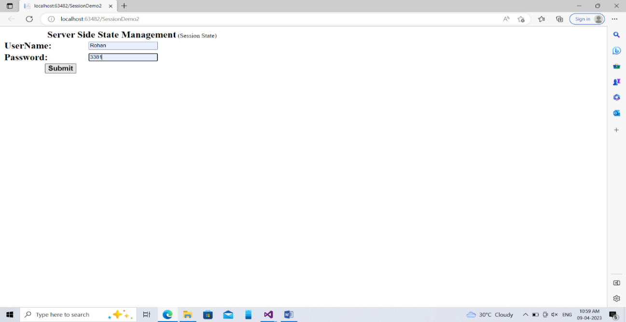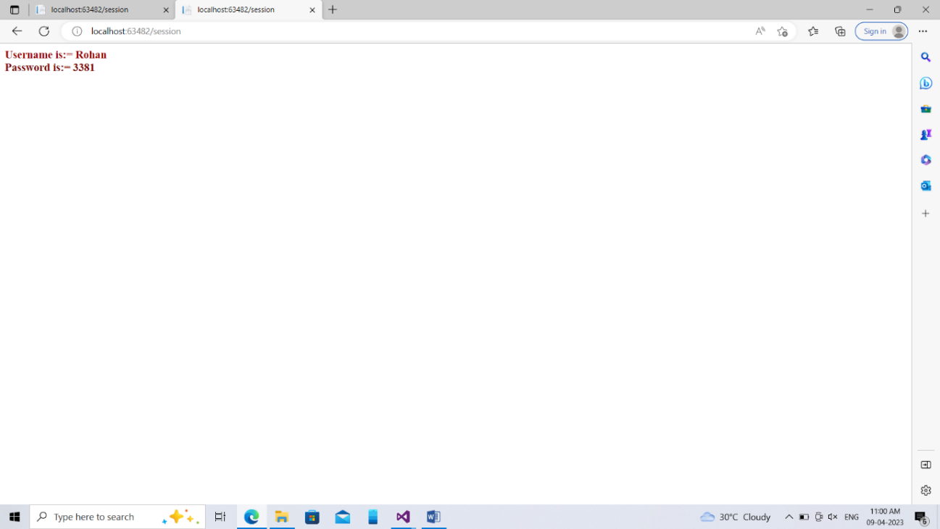

**2) Design Code** (*ApplicationStateDemo.aspx*)

<%@PageLanguage="C#"AutoEventWireup="true"CodeBehind="ApplicationStateDemo.aspx.cs"Inherits="ClientSideState.ApplicationStateDemo"%>

<!DOCTYPEhtml>

<htmlxmlns="http://www.w3.org/1999/xhtml">

<headrunat="server">

<title></title>

</head>

<body>

<formid="form1"runat="server">

<div>

&nbsp;&nbsp;&nbsp;&nbsp;&nbsp;&nbsp;&nbsp;&nbsp;&nbsp;&nbsp;&nbsp;&nbsp;&nbsp;&nbsp;&nbsp;&nbsp;&nbsp;&nbsp;&nbsp;&nbsp;&nbsp;&nbsp;&nbsp;&nbsp;&nbsp;&nbsp;&nbsp;&nbsp;&nbsp;&nbsp;&nbsp;&nbsp;&nbsp;&nbsp;&nbsp;&nbsp;&nbsp;&nbsp;&nbsp;&nbsp;

<asp:LabelID="Label2"runat="server"Font-Bold="True"Font-Size="Large"Text="Server Side State Management(Application State)"></asp:Label>

<br/>

<br/>

&nbsp;&nbsp;&nbsp;&nbsp;&nbsp;&nbsp;&nbsp;&nbsp;&nbsp;&nbsp;&nbsp;&nbsp;&nbsp;&nbsp;&nbsp;&nbsp;&nbsp;&nbsp;&nbsp;&nbsp;&nbsp;&nbsp;&nbsp;&nbsp;&nbsp;&nbsp;&nbsp;&nbsp;&nbsp;&nbsp;&nbsp;&nbsp;&nbsp;&nbsp;&nbsp;&nbsp;&nbsp;&nbsp;&nbsp;&nbsp;&nbsp;&nbsp;&nbsp;&nbsp;&nbsp;&nbsp;&nbsp;&nbsp;&nbsp;&nbsp;&nbsp;

<asp:ButtonID="Button1"runat="server"Font-Bold="True"Font-Size="Medium"OnClick="Button1_Click"Text="Total Visits"/>

&nbsp;&nbsp;&nbsp;&nbsp;&nbsp;&nbsp;&nbsp;&nbsp;&nbsp;&nbsp;&nbsp;&nbsp;&nbsp;&nbsp;&nbsp;&nbsp;&nbsp;&nbsp;&nbsp;&nbsp;&nbsp;&nbsp;&nbsp;&nbsp;

<asp:LabelID="Label1"runat="server"Font-Bold="True"Font-Size="Medium"Text="Label"></asp:Label>

</div>

</form>

<p>

s</p>

</body>

</html>

**Code: - (***ApplicationStateDemo.aspx.cs***)**

using System;

usingSystem.Collections.Generic;

usingSystem.Linq;

usingSystem.Web;

usingSystem.Web.UI;

usingSystem.Web.UI.WebControls;

namespaceClientSideState

{

publicpartialclassApplicationStateDemo : System.Web.UI.Page

{

protectedvoidPage_Load(object sender, EventArgs e)

{

// Application["visit"] = "google.com";

}

protectedvoid Button1_Click(object sender, EventArgs e)

{

int count = 0;

if(Application["Visit"]!=null)

{

count=Convert.ToInt32(Application["Visit"].ToString());

}

count = count + 1;

Application["Visit"] = count;

Label1.Text = "Total No Of Visits= " + count.ToString();

}

}

}

**\*\*\*\*\*\*\*\*\*\*\*\*\*\*\*\*\*\*\*\*\*\*OUTPUT\*\*\*\*\*\*\*\*\*\*\*\*\*\*\*\*\*\*\***

